SURREY COUNTY NETBALL ASSOCIATION

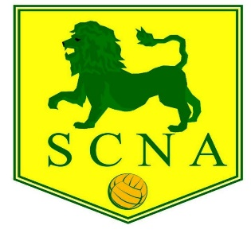

THE 91st ANNUAL GENERAL MEETING OF THE SURREY COUNTY NETBALL ASSOCIATION WILL BE HELD ON WEDNESDAY 5TH JUNE 2024 AT PURLEY SPORTS CLUB at 7.30pm for light refreshments and start of meeting at 8pm

AGENDA

- President’s Welcome Opening Address
- Apologies for Absence
- Minutes of the Previous Annual General Meeting 7 June 2023 at Purley Sports Club
- Matters Arising
- Reports from Executive Committee, Schools Section, Leagues including Junior league, NDO
- Presentation of Accounts for 2023/2024
- Membership fees for the season 2024/25
- Election of President, Vice President, and Officers (Chairman, Vice Chairman, Hon Secretary, Hon Treasurer, Membership Secretary/Asst Treasurer, County Officiating Lead, Assistant County Officiating Lead, Umpiring Mentoring Manager, Coaching Secretary, Communications/Publicity Secretary, County Safeguarding Officer, Regional Competition representative, Minuting Secretary, Schools Representative, County Performance Pathway Lead, Junior League Representative, Volunteer Officer, Diversity/Equalities Officer, County Resolution Lead, County Welfare Officer)
- County League - Presentation to winning club; and any proposed Rules change
- Surrey Lions awards presentations
- Any Other Business

Nominations for President, Vice President and Officers, and matters for ‘Any Other Business’ should be sent to Jackie Rowland at jbr51@hotmail.co.uk by FRIDAY 31st MAY 2024.

ck/jbr
25th March 2024

