SURREY COUNTY NETBALL ASSOCIATION

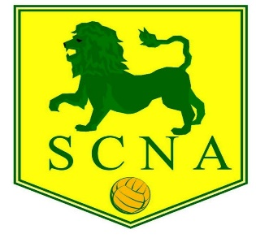

THE 89th ANNUAL GENERAL MEETING OF THE SURREY COUNTY NETBALL ASSOCIATION WILL BE HELD ON WEDNESDAY 8th JUNE 2022 AT PURLEY SPORTS CLUB at 7.30pm for 8pm

AGENDA

- Presidents Welcome Opening Address
- Apologies for Absence
- Minutes of the Previous Annual General Meeting
- Matters Arising
- Reports from Executive Committee, Schools Section, Leagues including Junior leagues, NDO
- Presentation of Accounts for 2021/2022
- Membership fees for the season 2022/23
- Election of President, Vice President, and Officers (Chairman, Vice Chairman, Hon Secretary, Hon Treasurer, Membership Secretary, Umpiring Secretary, Umpiring Mentoring Manager, Umpire Test Organiser, Coaching Secretary, Communications Secretary, County Safeguarding Officer, Regional Competition representative, Minuting Secretary, Schools Representative, County Performance Pathway Lead representative, Junior League Representative, Volunteer Officer)
- Vacancies - Tournament Secretary; Diversity/Equalities Officer;
- County League Rules
- Volunteer recognition
- Update on Officiating programme and route to qualification
- Dates for 2022/2023
- Any Other Business

Nominations for President, Vice President and Officers, and matters for ‘Any Other Business’ should be sent to Jackie Rowland at jbr51@hotmail.co.uk by FRIDAY 3rd June 2021.

ck/jbr
28th May 2022

