SURREY COUNTY NETBALL ASSOCIATION

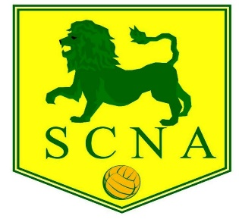

THE 88th ANNUAL GENERAL MEETING OF THE SURREY COUNTY NETBALL ASSOCIATION WILL BE HELD ON WEDNESDAY 30 JUNE AT PURLEY SPORTS CLUB AT 8PM (OR VIA ZOOM IF REQUIRED BY ANY CHANGES TO GOVERNMENT COVID RESTRICTIONS)

AGENDA

- Presidents Welcome Opening Address
- Apologies for Absence
- Minutes of the Previous Annual General Meeting
- Matters Arising
- Reports from Executive Committee, Schools Section, Leagues including Junior leagues, NDO
- Presentation of Accounts for 2020/2021
- Membership fees for the season 2021/2022
- Election of President, Vice President, and Officers (Chairman, Vice Chairman, Hon Secretary, Hon Treasurer, Membership Secretary, Umpiring Secretary, Umpiring Mentoring Manager, Umpire Test Organiser, Coaching Secretary, Communications Secretary, County Safeguarding Officer, Regional Competition representative, Minuting Secretary, Schools Representative, County Performance Pathway Lead representative, Junior League Representative, Volunteer Officer)
- Vacancies - Tournament Secretary; Diversity/Equalities Officer;
- County League Rules
- Volunteer recognition
- Update on Officiating programme and route to qualification
- County League rules
- Dates for 2020/2021
- Any Other Business

Nominations for President, Vice President and Officers, and matters for ‘Any Other Business’ should be sent to Jackie Rowland at jbr51@hotmail.co.uk by FRIDAY 25th June 2021.

CK/JNR

