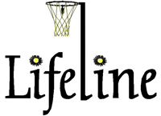
PRESS RELEASE
For immediate release 10 May 2013
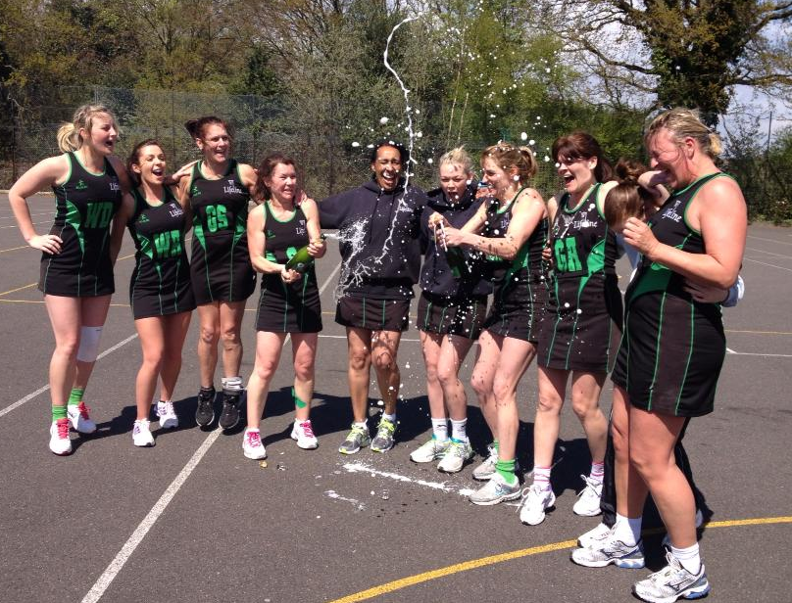
Lifeline A Team – winners of Division One, Croydon Netball League
L-R: Rachael Graham, Aimee Bare, Linda Orriss, Jody Carr, Lesley White, Emma Witcomb, Lynsey Danaher, Jo Crowhurst (c), Sally Whicher and Elaine South
Lifeline Netball Club are celebrating their best ever season with some great wins in several leagues. The club, based at Wallington Sports Club, have expanded over the past year thanks to the Back To Netball initiative that has seen club membership rise to over 65 members.
They have won their division in the evening Greenacres League, the Met A team have won Division 6 of the Metropolitan League and their A and C teams both won their divisions in the Croydon Netball League. The C Team only formed last year with Back To Netball players and have won Division 5 in their first season, whilst the A team were promoted to Division 1 last season and have immediately won that division, and will play in the Premier Division next season. Additionally, the B Team are looking likely to have been narrowly beaten into third in Division 4. over…
..cont.
Lifeline are pleased to have been involved with the Croydon Netball League’s recent Breast Cancer fundraiser which helped raise over £700 for the Rapid Diagnostic Assessment Centre at the Royal Marsden Sutton Hospital.
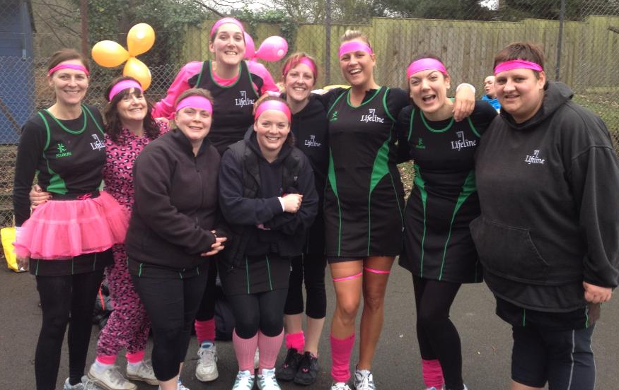

Lifeline C Team, winners of Division 5 of the Croydon Netball League, and supporters of the Breast Cancer fundraiser this March.
L-r: Lisa Hunt, Charlotte Ford, Sarah Wozniak, Zoe Cox, Kerri Armstrong, Sally-Ann Hatton, Natalie Murrell, Jo Parsons and Marlene Bassom (c)
Elaine South, coach, said “Lifeline Netball Club have enjoyed a fantastic season due to the hard work by players and coaches alike. We are all so proud of our achievements and are looking forward to putting the trophies on the shelf at Wallington Sports Club.”

For all details please see www.lifelinenetball.co.uk
Wallington Sports Club, Hillside Gardens, Wallington, Surrey SM6 9NX www.wallingtonsportsclub.co.uk
