London & South East  Regional Under 16 League Qualifying Tournament  Sunday 17th September 2017  Shirley High School,  Croydon, CR0 5EF  Entry Form | 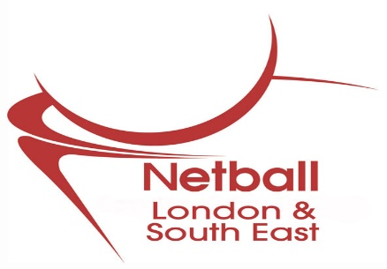

Name of Club: | CAPS Accredited: Yes/No  CAPS Registered: Yes/No
County: | England Netball ID No:

Club Colours:
Skirt: | Shirt: | Bibs: | Dress:

Club Contact:

Address: |  | Post Code:
Tel: (Day) | Tel: (Eve)
Email:

Entry fee of £80.00 + Deposit £100.00 = £180.00
Direct Payment to Santander 09-01-27, A/c 83956126, Ref ‘RLQTUN16 + CLUB NAME’
Closing date: Monday 4th September 2017
I confirm that I have read and understood the Rules & Regulations of the Regional U16 League Qualifying Tournament and that by signing this form I indicate the willingness of our Club to comply

Signed: | Print Name:
Position: | Date:

UMPIRE DETAILS
Name | EN ID Number | Qualification
Address

e-mail | Mobile ‘phone:  Home ‘phone:

Return to: Jenny Harrold - jennyharrold@btinternet.com
and Julia Martin – trmb.lserna@gmail.com

