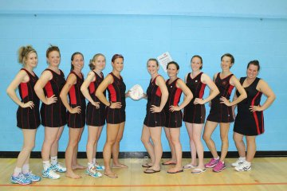

GEMS

NETBALL

CLUB BASED IN

NEW MALDEN

PLAY GAMES IN

CHEAM
SOME OF OUR PLAYERS LOOKING READY FOR ACTION

WE ARE KEEN TO ADD TO OUR MEMBERSHIP FOR THIS SEASON, ESPECIALLY
ANY CIRCLE DEFENDERS.
WE HAVE AN EXCELLENT LEVEL 2 COACH WHO TRAINS US ON A TUESDAY FROM
8 UNTIL 9.30. INDOORS AT HOLY CROSS SCHOOL SANDAL ROAD NEW MALDEN.
WE PLAY IN THE SURREY AND KINGSTON LEAGUES SO WE HAVE MATCHES EVERY SATURDAY.
WE HAVE SEVERAL SOCIAL GATHERINGS AS WE ARE A VERY FRIENDLY BUNCH OF LADIES WHO HAVE OF COURSE A COMPETITIVE EDGE TO HELP US WORK HARD AND ENJOY THE SUCCESSES OF THE CLUB.
PLEASE EMAIL JOAN 42chips@gmail.com EVERYONE WELCOME TO COME AND MEET US ESPECIALLY IF YOU ARE A DEFENDER.

